**Deliverable 1: Project Charter/Study Report**

**1.Purpose**

The purpose of this project is to assist Happy Valley Kennel in building an improved system to help manage day-to-day operations. The overall goal is to help automate their “Reservation and Care System”. The primary needs we have identified include a website to assist in automating the reservation system. Our suggested website package comes from WordPress, which provides a domain with additional features including powerful tools in a user-friendly format. Second, prioritizing good customers and pets in an effort to retain good business and avoid less desirable customers. This effort will be aided by providing visual analytics to help business management better understand the quality of customers. Third, hiring an office manager who has some knowledge about basic Microsoft Office tools to help record and manage data.

**2. Description**

**2.1. History**

The current system in place is manually intensive and relies heavily on handwritten and verbal communication as well as individual judgment. Sometimes necessary information is forgotten or misplaced due to human error. If the kennel is busy, there can be a lack of consistency. Based on our interviews with the stakeholder, 75% of customers call ahead to make appointments, the other 25% are walk-ins. Currently, there are no medical documents required of dogs that stay at the kennel. When a customer arrives, an employee will check in the guest dog by filling out a kennel card or updating one if they are a returning customer. The customer will then provide information that will be recorded on the kennel card such as basic information, and any specific needs. The employee manually transfers data over from the Kennel Card a contract, which is then signed by the customer. The dog is then assigned to a run, which is then documented on the Kennel Log.

The proposed project scope includes automating the process of registering the dog and checking in for an appointment. In addition to automation, the addition of an office manager who can handle the operations of the kennel on a day-to-day basis as well as utilize basic data tools to better understand the quality of customers.

**2.2. Scope**

**Current Business Functions:** *Illustrated through Context Diagram*

***Main Process:*** Happy Valley Kennel, Inc: Process provides care to customer’s pets. Main process includes lower processes such as booking, scheduling, ordering, etc.

***Reservation/Booking Process Background:*** Approximately 75% of books are completed via telephone. The Kennel card is either pulled from files and updated or created on the spot. The kennel card is a small card containing information on dog as well as customer such as residence, emergency contact number, veterinarian, food preferences, medications, dog name, sex, spayed/neutered, breed, age, and dietary needs. The data from the kennel card is then transferred over to the contract to which the customer will sign off on. The contract includes personal items to prevent forgetting items when they leave. A general notes area is provided, where any unusual or concerning behavior may be recorded.

**External Entities:**

***Customers:*** External actor owns pet who initiates scheduling appointment, drops off pet for scheduled appointment, and finally makes payment during pet pickup.

***Suppliers:*** External entity that receives orders from Happy Valley Kennel Inc. and provides invoice and delivery of requested items.

**Veterinarian:** External actor that receives sick pet during appointment. Provides service invoice to Happy Valley Kennel.

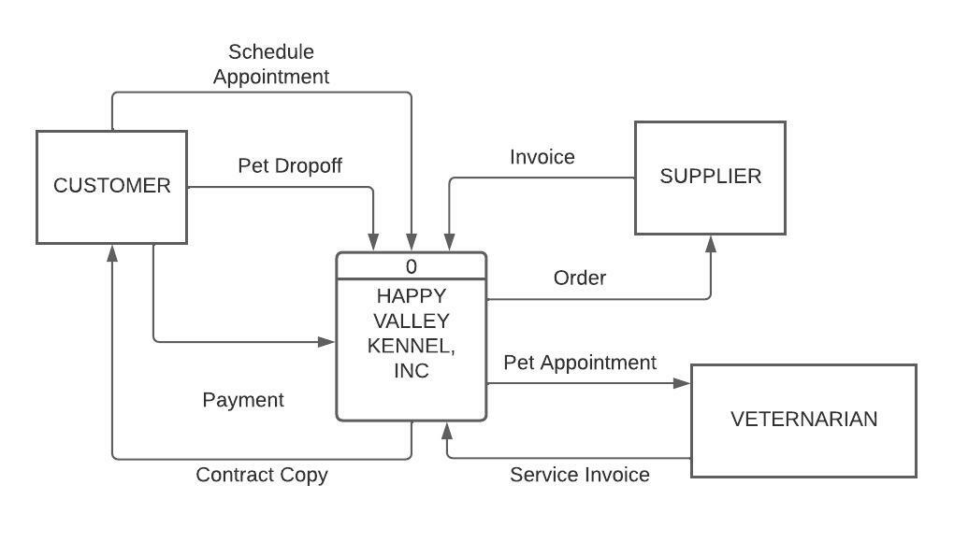

**Current Business Functions:** *Illustrated through UML (Use Case) Diagram*

***Schedule Appointment:*** *A customer/actor calls Happy Kennel Valley to schedule a future appointment.*

***Drop off Pet:***Customer/Actor brings pet for scheduled appointment or a “walk-in”. Customer/Actor then leaves the pet with an employee for stay. When the actor/customer drops off pet, they will sign the provided contract.

***Sign Contract:*** Once a customer/actor drops off pet, a contract is drawn and then signed by the customer/actor to establish policies and expectations.

***Create Run Assignment:***A run is a 4x20 ft indoor/outdoor cage with a pulley metal door to allow for seamless access to both indoors and outdoors. Certain dogs are placed in varying sizes/directional cages depending on their size, habits, duration of stay, and availability. The data is kept on the Kennel Log, which is a list of names of all the dogs in residence at the time as well as food preferences.

***Update Kennel Card:*** *An employee/actor pulls the kennel card from record and manually updates basic customer information. During stay, employee makes notes on kennel card. The customer/actor does not have access to this function.*

***Update Kennel Log:*** *An employee/actor records the run assignment, food preferences, medications, etc. for pet. This occurs after pet drop off.*

***Use Case Diagram:*** The current system lacks automation (*see UML Diagram 1*), which explains the missing automation border. The proposed system *(see UML Diagram 2)* allows for increased automation for both the customer and employee. The new process includes the addition of an operations manager who will have the reporting capabilities as well as the same capabilities as the part-time worker. Primary processes that are automated in the proposed system include adding/updating the schedule calendar, updating customer profile, updating virtual kennel log, and virtual kennel card via the proposed website. Finally, customers are able to make payments online.

*CURRENT SYSTEM (UML DIAGRAM 1)*

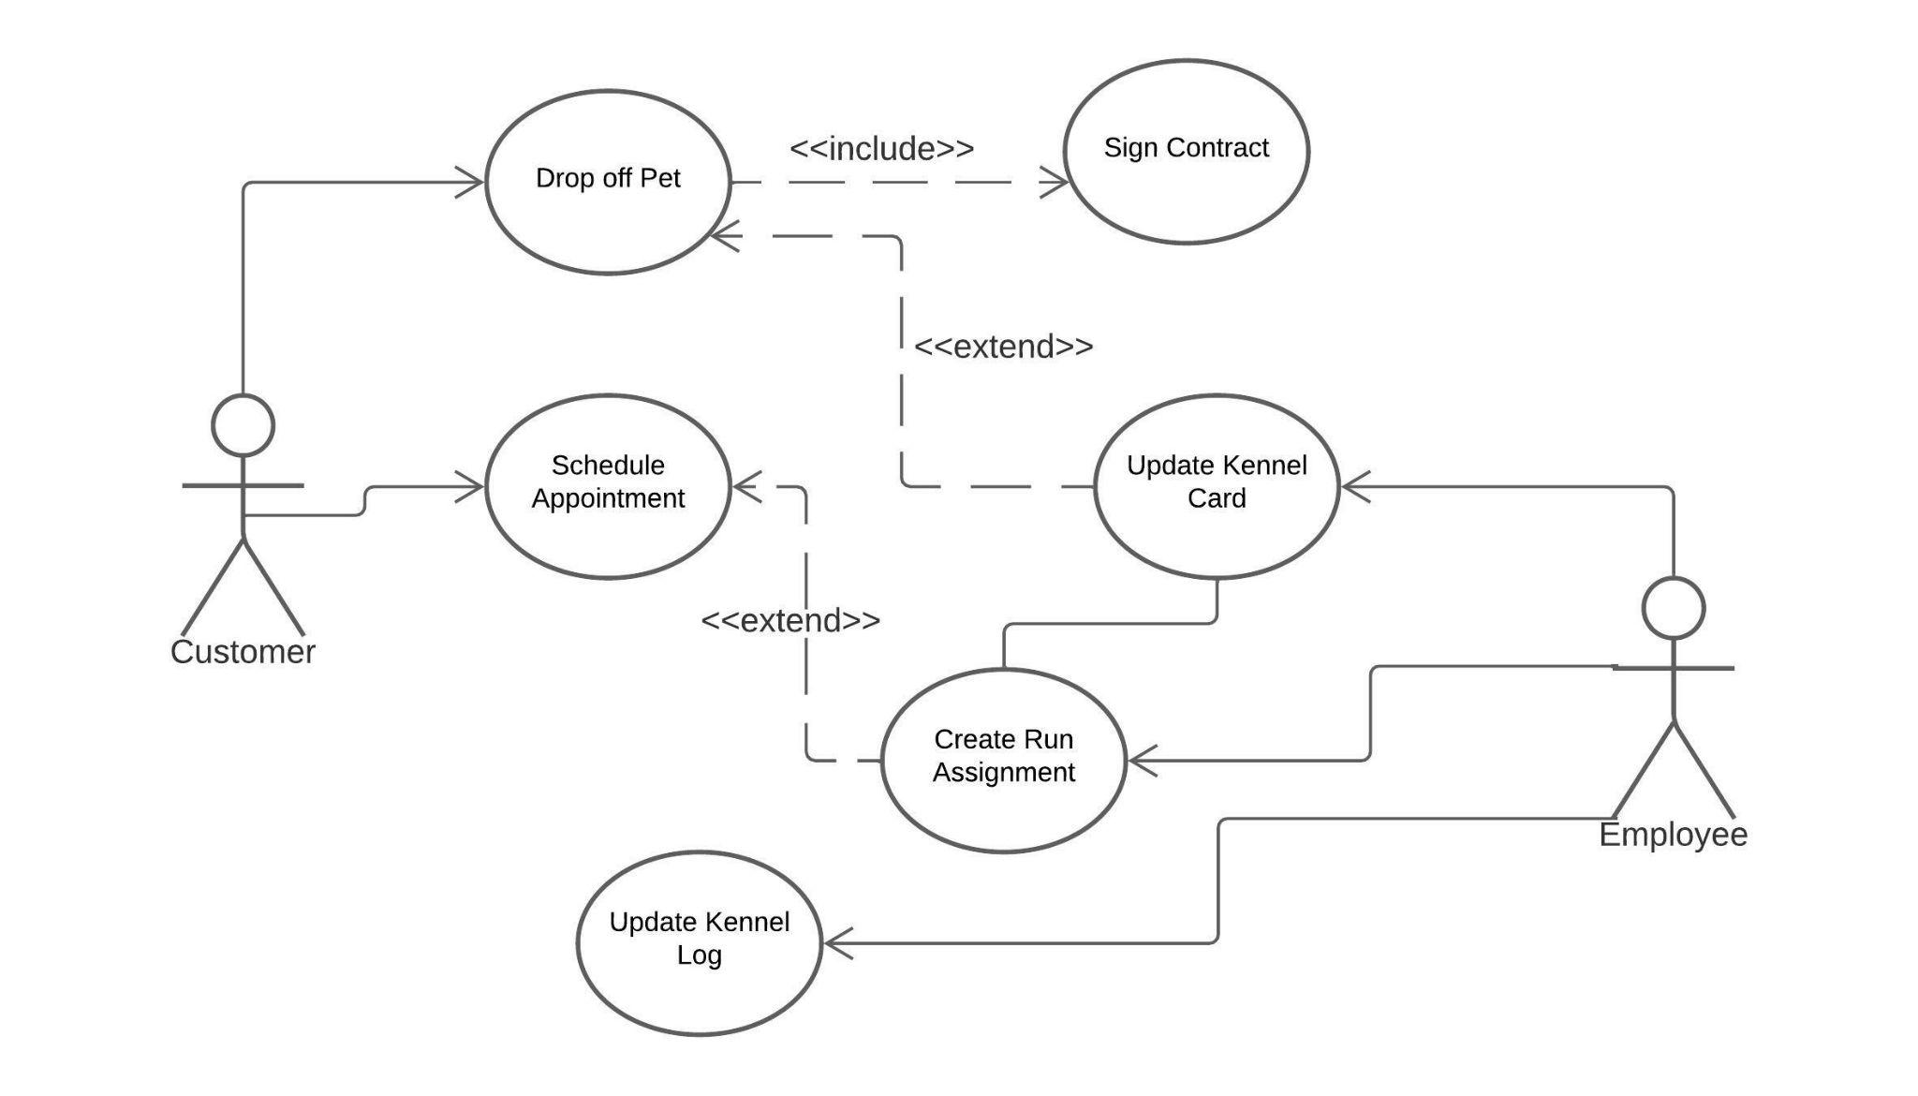

*PROPOSED SYSTEM (UML DIAGRAM 2)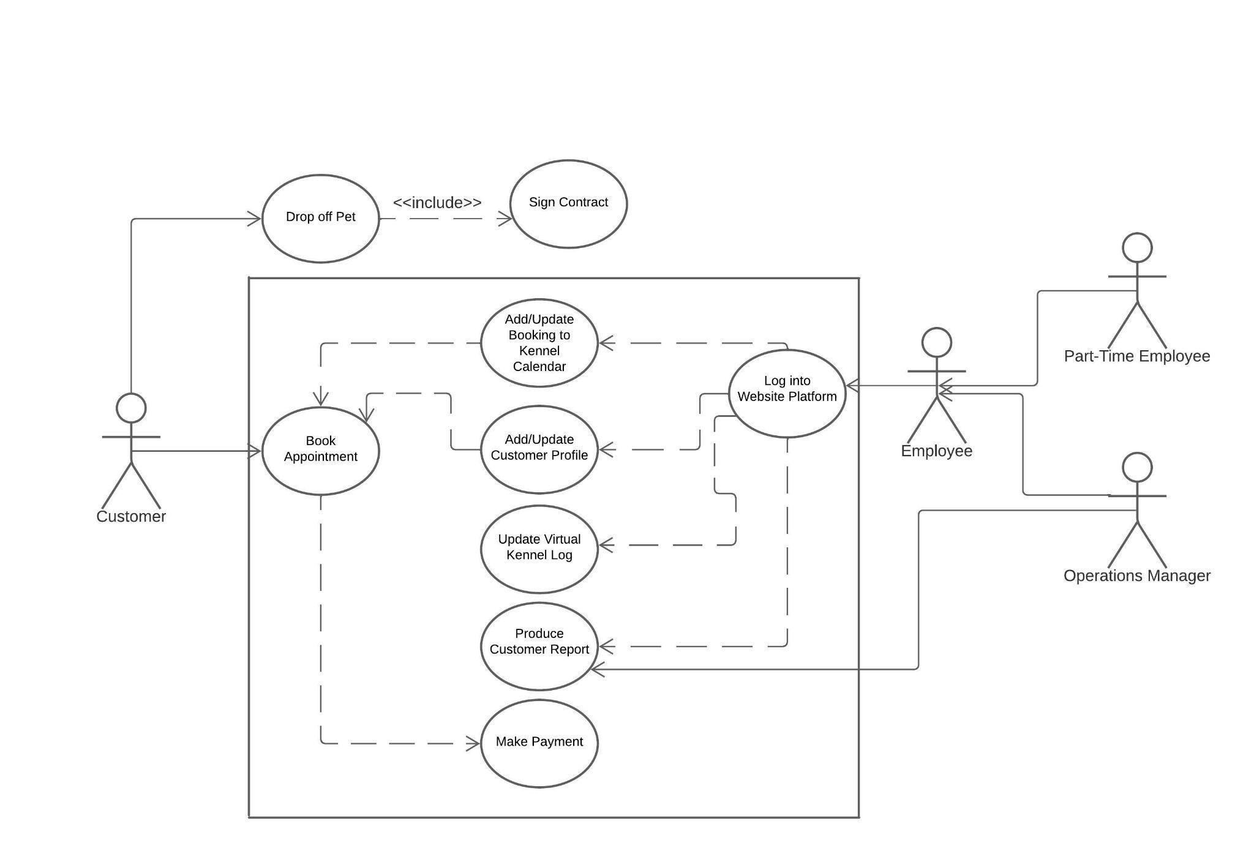*

**3. Project Environment**

**3.1. Participants**

**3.1.1. Management**

|  |  |
| --- | --- |
| Jim Read | Co-Owner of Happy Valley Kennel/Supply Manager |
| Sally Read | Co-Owner of Happy Valley Kennel/Operations Manager (current) |

**3.1.2. Non-Management**

|  |  |
| --- | --- |
| Jack | Part-Time Staffer |
| Customers | Consumer of services |

**3.1.3. Other Participants**

|  |  |
| --- | --- |
| Suppliers | Provide supplies such as food, treats, materials for business |
| Veterinarian | In case of emergency or illness, pets brought to treat ailments |

**3.1.4. Project Team Members**

|  |  |
| --- | --- |
| Keyur Shah | Team Leader |
| Laine Perry | Team Facilitator |
| Sruthi Kalidindi | Team Broker |
| Gowtham Reddy Kota | Team Monitor |

**3.2. Problems and Opportunities**

**3.2.1. Problem 1:Distinguishing Good Customers from Less Desirable Customers**

*Good Customers:*

* + 1. Use services often
    2. Follow through regularly on appointments
    3. Advocate for Happy Valley Kennel to other potential customers
    4. Vaccinates and spays/neuters pet, keeps pet up to date on health

*Poor Customers:*

* + 1. Schedules appointment and does not show up to appointment
    2. Consistently late to pick up pet from kennel
    3. Unfriendly pets or ill-mannered pets that create tension in kennel
    4. Unvaccinated pet, not up to date on health checks
    5. Fails to honor signed contract agreement

**3.2.2. Problem 2: Manually Intensive Processes**

1. Leads to errors and inconsistency in customer and pet data.
2. Potential to misplace records of customers and pets.
3. Time-intensive for employees and owners.

**3.2.3. Problem 3: Requires Too Much Oversight from Owners**

1. Time could be better spent investing elsewhere or in other interests.
2. Over-exhausting work can lead to burnout.
3. Difficult for owners to step away from business

**3.2.4. Problem 4: No Set Policy on Vaccinations or Health Checks**

1. Unable to easily track vaccinations and health checks without creating more work for employees.
2. “Good” customers may not return if they feel their pet is not safe or is at risk.
3. Pets that become sick are then taken to the veterinarian. This costs more time and money on both the owners and customers.

**3.2.5. Opportunity 1: Website Investment**

1. Investing in a website service will provide Happy Valley Kennel an easy to manage booking system, data storage for customer records, ability to report on good and less desirable customers.
2. Automating the booking process and creating a website will expand awareness to potential customers.
3. Most importantly, it reduces manual work through automating the booking process and tools such as the Kennel Card and Kennel Log.

**3.2.6. Opportunity 2: Hire Operations Manager**

1. Hiring a full-time Operations or IT Manager who will take care of daily tasks and day-to-day operations.
2. The manager will be responsible for updating the website as well as functional tasks for the kennel.
3. Website responsibilities could include updating basic information, posting photos, creating reports on customers, etc.

**3.2.7. Opportunity 3: Retain Good Customers**

1. Retain good customers by offering discounts and loyalty programs for returning customers.
2. Attaining visual or graphic reports based on customer data and behavior through data visualization will easily distinguish positive patterns in customers that can then be rewarded. For example, customers who refer others to Happy Valley Kennel could be provided a reference discount. Data visualization could include how often a customer uses services, track appointments, cancellations, no shows, etc.

**3.3. Constraints**

**3.3.1.** Current employees may not have the skill/knowledge to operate a new system.

**3.3.2.** Limitation on budget may not be sufficient for all requests

**3.3.3.** Time will need to be spent to train new employees as well as existing employees on the new system.

**3.3.4.** Addition of new features or additional requests could impact the critical path for this project. Could risk a decrease in quality performance.

**3.3.5.** Failure to anticipate potential risks or problems may affect the timeline.

**3.4. Vision**

The vision of the project is to create an information system for Happy Valley Kennels Inc. and help them to compete with their competitors by giving them the best information system and benchmark their service offerings.

**4. Preliminary Investigation**

**4.1.Findings and Analysis:**

Proposed Procedure Outline:

1. Planning Phase/Fact-Finding Phase
2. Understand what needs to be automated
3. Hire Operations Manager with some IT background
4. Develop Website
5. Train on new system
6. Implementation Phase

**4.2. Preliminary Solutions and Ideas:**

***4.2.1. Develop Website:*** Using the telephone as the primary tool to schedule a visit is time-consuming for employees and can take away from the provided care of pets. Phone calls also limit the number of customers who can schedule appointments. Since the internet is widely available, using an online form through a website saves time for both the customer and employees. Phone calls and walk-ins will still be available but less common. Additionally, a website provides numerous opportunities to keep customers up to date on promotions, events, hours, or provide images of the facility.

A website can replace your current Kennel Card filing system. A website will provide storage to record details about individual pets and customers. The database will be able to hold information about individual pets and customers. Additionally, in the effort to retain good customers and pets with good health, a website can maintain records of veterinarian visits from the kennel for treatment. The system analyst team has provided a table of two potential online Scheduling/website packages the stakeholder can review and potentially select *(see table 1).*

***Website Database Use Example:*** A single pet ID can identify information such as food preferences, vaccinations, allergies, owner’s address, emergency number, special request, type of breed, and also details of run time; all data is retrieved from online form to this system. A database provides a source to use when creating visual representations of data for good and less desirable customers.

*Table 1: Systems Examples and their Features*

|  |  |  |
| --- | --- | --- |
| **FEATURES** | **OPTION 1** | **OPTION 2** |
| **System Name** | **SimplyBook**  **(Recommended)** | **Acuity Scheduling** |
| **Website (Included)** | **✔** |  |
| **Booking/Scheduling Automation** | **✔** | **✔** |
| *Number of Appointments/Services* | 2000/month | Unlimited |
| *Online Booking* | **✔** | **✔** |
| *Intake Forms* | **✔** |  |
| *Sync with Calendar (Google Calendar, Outlook, etc.)* | **✔** | **✔** |
| *Online Payments* | **✔** | **✔** |
| **Retaining Good Customers** |  |  |
| *Offer Discounts/Coupons/Gift Cards* | **✔** | **✔** |
| *Loyalty Program* | **✔** |  |
| *Statistics & Analytics* | **✔** | **✔** |
| *Data Visualization (included)* | **✔** |  |
| *Data Visualization (Indirect)* |  | **✔** |
| **Additional Automation Capabilities** |  |  |
| *Mobile App* | **✔** |  |
| *Daily Reports* | **✔** |  |
| *QuickBooks for Invoice and Accounting* |  | **✔** |

**4.2.2. Hiring Operations/IT Manager:** Managing a business is incredibly cumbersome. It can be difficult to be responsible for the entire system. Hiring an operations manager will allow the stakeholder to hold an overseer role and choose to be less involved in the day-to-day operations. It will also provide time to expand different areas of the business or simply take time away from work. Many business proprietors hire managers once an operation becomes too large.

**4.3.Feasibility Studies**

**4.3.1. Operational Feasibility:** Websites reduce handwritten work of the current kennel card and phone call booking systems. The manual operations and phone call booking are time-consuming. A website reduces time spent recording data by providing automation and less human intervention. A website can lead to business growth and reaches people outside a business’s regular foot traffic

**4.3.2. Economic Feasibility:** Some of the economic factors include purchase of a website, the new employee salary, and maintaining the facility. One-time costs such as the cost of the system analyst team will not be recurring over the next planned 10 years. Although the costs are high, the benefits will be a factor in the overall decision of the stakeholder. For example, the cost of the website will be another great annual expense, but will greatly free up employee time, which will ultimately allow for more efficiency in their jobs and end up providing higher quality work. Additionally, hiring an operations manager is the largest expense in the budget, however, it will not only improve the quality of life of the stakeholder, but also provide an experienced professional to operate the day-to-day business. Depending on which website option the stakeholder selects, will determine the amount of skill the new professional should have. Option 1, SimplyBook, is very user friendly and requires minimal technical skills to run reports and create data visualizations. Option 2, however, requires a slightly more technical individual to run reports and analyze data.

**4.3.3. Technical Feasibility:** The first website for small businesses required web form, data of customer and may potentially need a technical person to handle the website, depending on which option the stakeholder selects. The business has a lot of potential to grow and expand in the near future. The website will contain about 10 - 15 pages.

**4.3.4. Schedule Feasibility:** First, we provide two website package options for the stakeholder to select from. During that same time, the search for an operations manager can take place. Once the manager is hired, training can begin. Once a web package is selected, design and setup can take place, which finally ends with implementation.

**5.Project Plan Schedule**

**5.1 The Project Plan Schedule** includes Project start date and end date. The start date of the Project Design Phase starts from February 1st and Ends on April 27th. The implementation phase starts from May 1st to June 30th.  
**5.2. Project Evaluation Review Technique (PERT)/Critical Path Methods (CPM)**

**5.2.1. Activities and Sub-Activities**

1. Planning
2. Research

* Hire Manager
* Onboard Manager

1. Design

* Purchase Website Package
* Approve Website Design
* Complete Website
* Activate Website
* Tracking SEO and Service Interaction
* Implementing Rewards / Discounts
* Follow up

**5.2.2. Program Evaluation Review Technique (PERT) Chart**

PERT Chart helps to Identify the Project Activities and the estimate of how much time each task will take to perform.

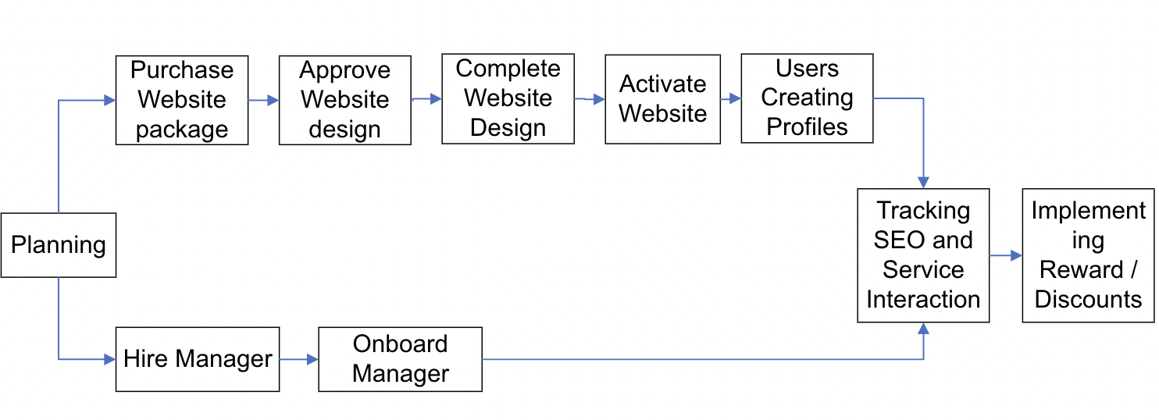

**5.3. Calculating the Critical Path**

In order to create a Critical Path we would need different Time Estimates:  
 Earliest Finish = Earliest Start + Activity Time  
 Latest Start = Latest Finish - Activity Time  
 Slack = Earliest Start - Latest Start  
 Or  
 Slack = Earliest Finish - Latest Finish

|  |  |  |
| --- | --- | --- |
| Activity | Earliest Start | Earliest Finish |
| Activity Time | Latest Start | Latest Finish |

*(See following page for details)*

|  |  |  |  |  |  |  |  |  |  |  |
| --- | --- | --- | --- | --- | --- | --- | --- | --- | --- | --- |
| ACTUAL ACTIVITY | Planning | Purchase Website Package | Hire Manager | Approve Website Design | Onboard Manager | Complete Website Design | Activate website | User Creating Profiles | Tracking SEO and Service interaction | Implement  Rewards / Discounts |
| ACTIVITY | A | B | C | D | E | F | G | H | I | J |
| IMMEDIATE PREDECESSORS | - | A | A | B | C | D | F | G | H,E | I |
| EXPECTED TIME (WEEKS) | 4 | 1 | 1 | 1 | 1 | 2 | 2 | 1 | 3 | 4 |

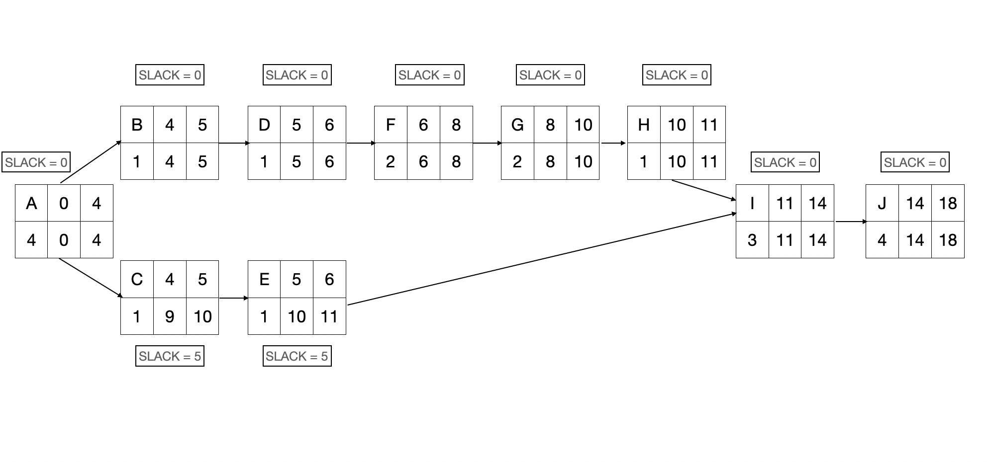

Critical Path of the Project would be **PLANNING → PURCHASE WEBSITE PACKAGE → APPROVE WEBSITE DESIGN → COMPLETE WEBSITE DESIGN → ACTIVATE WEBSITE → USER CREATING PROFILES → TRACKING SEO AND SERVICE INTERACTION → IMPLEMENTING REWARDS / DISCOUNTS.**

These Activities can't be delayed without extending the Project completion time.

Activities **HIRE MANAGER → ONBOARD MANAGER** can Start between Week 4 & 9 and End between Week 6 & 11.

**6.Project Budget**

**Estimated Budget:** $120,000 - $150,000

**Total Cost of Ownership (TCO):**

***Website:*** Depending on which option stakeholder chooses, the website package will cost between $540 and $600 per year. This will cover costs for features including booking system, payment system, mobile application capabilities.

***Operations Manager:*** Depending on skill levels of individuals hired, this position will be salaried from $70k - 100k. New hire will be responsible for running the new automated operations.

***Systems Analysts:*** At a rate of $45/hour for a team of 4, the total estimated cost will be around $25,600 for the duration of our work over 4 weeks.

***Web Domain:*** Required for Option 2 with Acuity Scheduling. To acquire the same capabilities as SimplyBook, a website package through SquareSpace would provide a platform for the scheduling system.

**Total Cost of Ownership = Website + Operations Manager + Web Domain (optional) + Tax**

|  |  |  |  |  |  |  |  |  |  |
| --- | --- | --- | --- | --- | --- | --- | --- | --- | --- |
| TCO | [1][2]Website  (OPTIONS) | | [3]Operations Manager  (OPTIONS) | | [4]Systems Analysts | [5]Website Domain | [6]Tax | TOTAL  (OPTIONS) | |
| YR | 1 | 2 | 1 | 2 |  |  |  | 1 | 2 |
| 1 | $600 | $540 | $75,000 | $90,000 | $25,600 | $17.00 | $50 | $101,267 | 116,174 |
| 2 | $600 | $540 | $75,000 | $90,000 | - | $17.00 | $50 | $75,667 | $90,607 |
| 3 | $600 | $540 | $75,000 | $90,000 | - | $17.00 | $50 | $75,667 | $90,607 |
| 4 | $600 | $540 | $75,000 | $90,000 | - | $17.00 | $50 | $75,667 | $90,607 |
| 5 | $600 | $540 | $75,000 | $90,000 | - | $17.00 | $50 | $75,667 | $90,607 |
| 6 | $600 | $540 | $75,000 | $90,000 | - | $17.00 | $50 | $75,667 | $90,607 |
| 7 | $600 | $540 | $75,000 | $90,000 | - | $17.00 | $50 | $75,667 | $90,607 |
| 8 | $600 | $540 | $75,000 | $90,000 | - | $17.00 | $50 | $75,667 | $90,607 |
| 9 | $600 | $540 | $75,000 | $90,000 | - | $17.00 | $50 | $75,667 | $90,607 |
| 10 | $600 | $540 | $75,000 | $90,000 | - | $17.00 | $50 | $75,667 | $90,607 |

**7.Documentation and Communication**

* Presentations and Project deliverables which are created to submit to stakeholder.
* Project Documentation Starts from the fact-finding phase and continues during the Implementation Phase.
* Issue logs will be created with the Errors or issues we face during the implementation of the Project.
* Document the Changes that are made when we work on implementing the Design.
* All the documents will be stored in Google Drive.
* Stakeholder Interviews and Communication through Reggienet.
* Project Meetings which are held on Zoom and In-person.
* Conversation through Outlook if there is anything to update something among the team members or to the Stakeholder.

**8.Conclusion**

To conclude, the primary objective of this project is to automate and improve the current reservation and booking system for the Happy Valley Kennel, Inc. This objective will be accomplished through several processes. First, developing a website will assist in the automation of booking through a reservation/booking form, contain a user-friendly interface, provide basic business information, and more. The systems analyst team provided information on two options that the stakeholder can consider. Second, an operations manager will greatly relieve the current operations manager and allow business owners to pursue different ventures. The hiring manager will handle day-to-day operations and maintain the new automated system. Although it will cost time and money to train, the benefits will outweigh the cost. Finally, in an effort to retain good customers, both website packages provided have the potential to keep a customer database to track current and future customers. Using this data, during the implementation phase, data visualization can be used to help stakeholders better understand their customer base and reward good customers with things such as discounts or loyalty programs.

1. SimplyBook Premium Cost: <https://simplybook.me/en/pricing>
2. Acuity Scheduling Powerhouse Cost: <https://acuityscheduling.com/signup.php>
3. Operations/IT Manager Salary: <https://www.payscale.com/research/US/Job=Technology_Manager/Salary>
4. Systems Analysts Consulting cost: <https://www.ziprecruiter.com/Salaries/Systems-Analyst-Consultant-Salary>
5. Website Domain Cost: <https://www.squarespace.com/pricing>
6. Sales Tax in Illinois (include Local): <https://www.salestaxhandbook.com/illinois/rates>